Phase 1
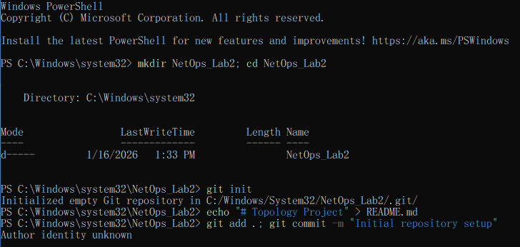
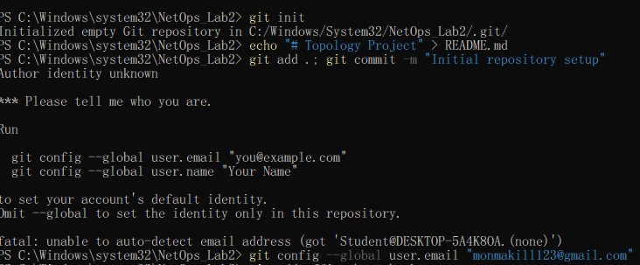

Phase 2
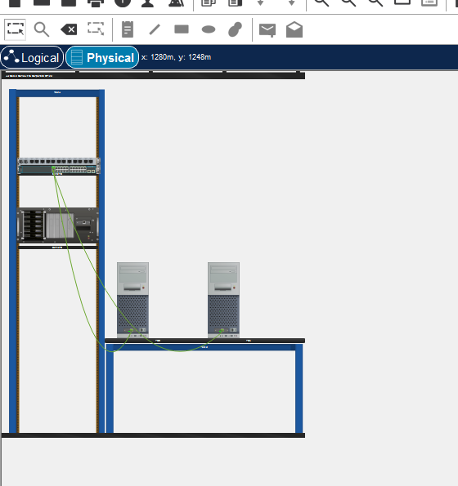

Phase 3
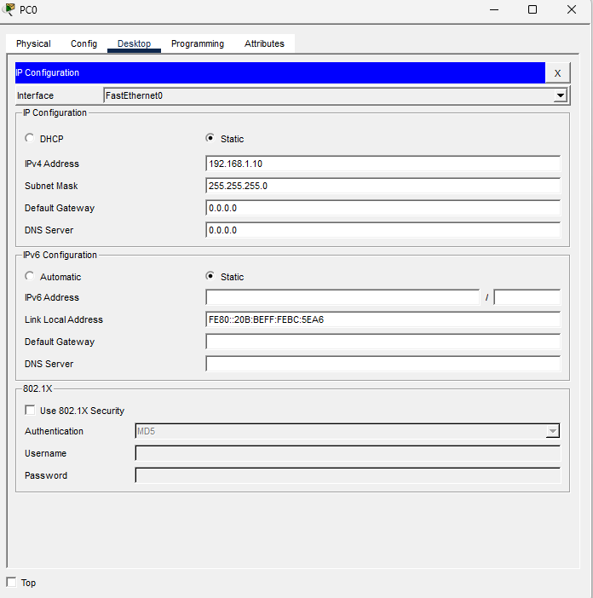

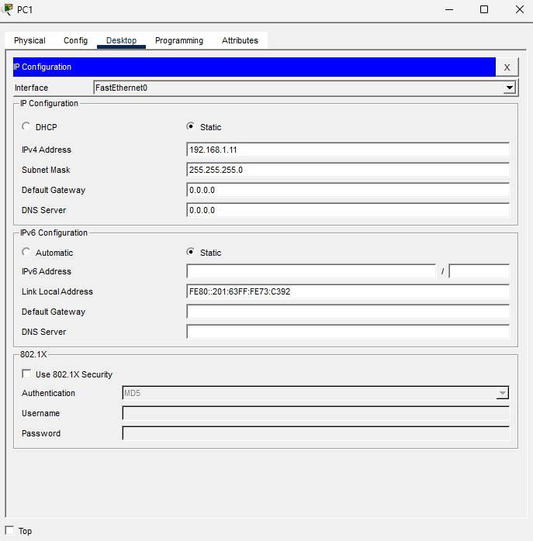

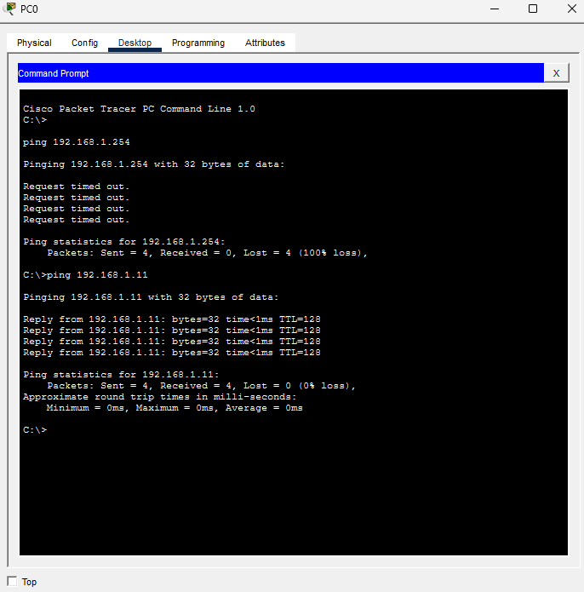
Phase 4: The Challenge Question
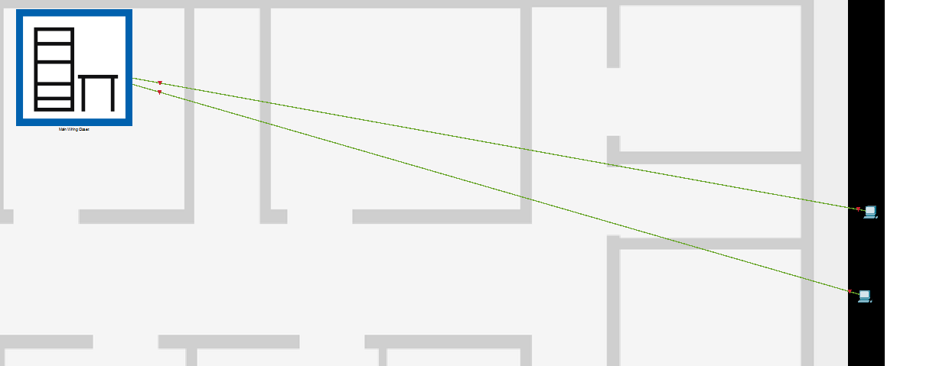
The Scenario: A manager asks you to move PC1 to a "Guest" room 100 meters away.
Ans: When the distance exceeds 100 meters, the link lights on the cable turn red, indicating the connection is lost.

